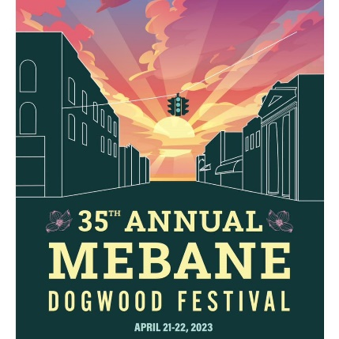
35th Annual Mebane Dogwood Festival
Online Auction
April 12 – 21, 2023

MBA Auction Rules

In 2023, the Mebane Business Association will continue the tradition of having our annual auction in support of various community events and projects, including supporting our schools, scholarships and more.

To increase the opportunity for all to have access to the auction items and broaden awareness of the MBA, we will be introducing an online auction, through Bidding Owl. You can sign onto their site and search for Mebane Business Association (www.biddingowl.com/MebaneBusinessAssociation).

The auction will be live beginning April 12th!

Sign up as a bidder on BiddingOwl.com to place your bids. Make sure to also select the option to receive notice if you are out-bid. This is a great opportunity to have our members and community join in the fun to win some fantastic items provided by our community partners!

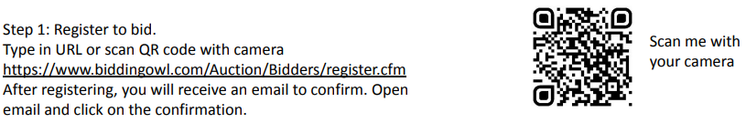

Winning bidders will receive a text message to notify them if they’ve won an item. You will then click on the “Check Out” link and follow the instructions to complete your payment.

Winning bidders and donors will be sent an email with contact information for each to make arrangements to collect their item(s). In the event the MBA is in possession of the item, the MBA will make arrangements with the bidder to collect the item(s).

The auction will end at 5pm on April 21st, 2023.

Thank you for participating in the MBA Dogwood Festival Auction. For more information on the MBA, please visit MBAMebane.com or call 919-304-3737.

Happy Bidding!

300 West Crawford Street, Suite C ∙ Mebane, NC 27302 ∙ mebanebusinessassociation@gmail.com

